**ASSIGNMENT-3**

IBM Cloud

|  |  |
| --- | --- |
| Assignment Date | 31 October 2022 |
| Student Name | Nandhini.K |
| Student Roll Number | 610519104068 |
| Maximum marks | 2Marks |

1. Create a Bucket in IBM object storage.
2. Upload an 5 images  to IBM object storage and make it public. Write html code to displaying all the 5 images.
3. Upload a CSS page to the object storage and use the same page in your HTML code.

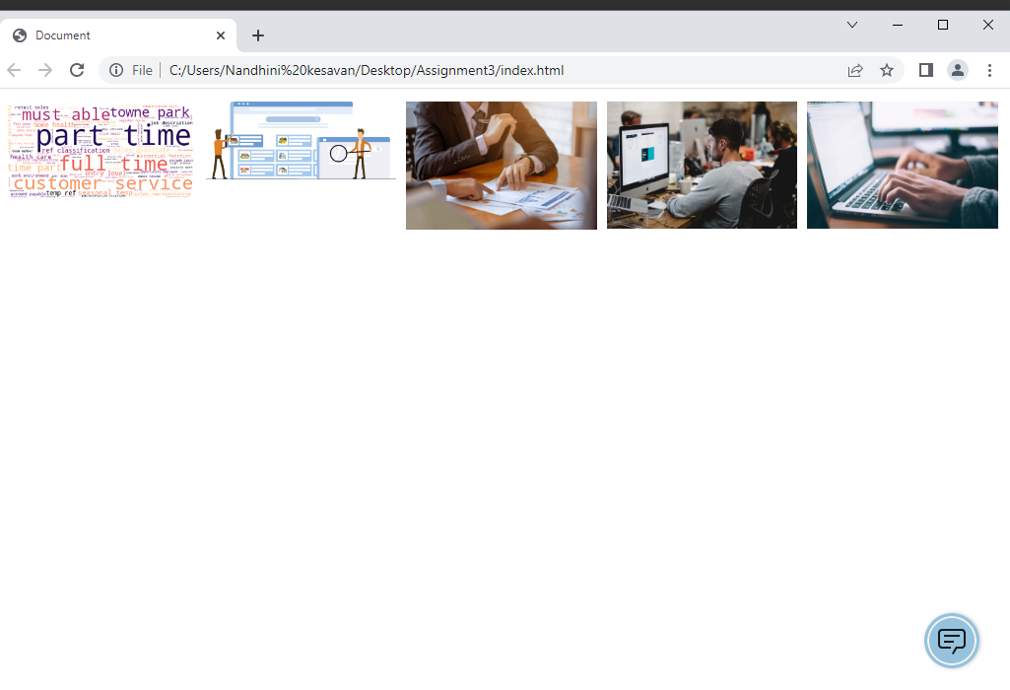

1. Design a chatbot using IBM Watson assistant for hospital. Ex: User comes with query to know the branches for that hospital in your city. Submit the web URL of that chat bot as an assignment.

URL of chat bot : <https://web-chat.global.assistant.watson.appdomain.cloud/preview.html?backgroundImageURL=https%3A%2F%2Fau-syd.assistant.watson.cloud.ibm.com%2Fpublic%2Fimages%2Fupx-0f887b02-173f-4aa5-8cd1-2358a051f3f8%3A%3A4d433eba-bc37-46a9-8d0b-ee2df94cb2dc&integrationID=ca05c8d2-c38b-42b9-86f1-c58b0e485283&region=au-syd&serviceInstanceID=0f887b02-173f-4aa5-8cd1-2358a051f3f8>

1. Create Watson assistant service with 10 steps and use 3 conditions in it. Load that script in HTML page.

